|  |
| --- |
| PT. BERLIAN SISTEM INFORMASI |
| Operating Lease – Procurement Management Process |
| USER MANUAL GUIDE |
|  |
| **VERSION 1.0** |
| **5/24/2016** |

|  |
| --- |
| All material contained in this manual including text, graphics, icons and images contain proprietary and confidential information of PT. Berlian Sistem Informasi and are protected by international intellectual property and other laws. The compilation of all text, graphics, icons and images in this Manual is the exclusive property of PT. Berlian Sistem Informasi. No modification, rental, lease, sale, transmission, distribution, reposting or creation or derivate works based on the material in this Manual is allowed, unless with the express permission of PT. Berlian Sistem Informasi. |

# REVISION HISTORY

|  |  |  |  |
| --- | --- | --- | --- |
| Date | Revision | Description | Author |
| 3/21/2016 | 0.0 | Initial Document | Sabilla Pravita Larassati |
| 3/29/2016 | 0.1 | Update Capture | AR. Anggun Cahyaningtyas |
| 4/14/2016 | 0.2 | Update Capture | AR. Anggun Cahyaningtyas |
| 5/6/2016 | 0.3 | Update Capture | AR. Anggun Cahyaningtyas |
| 5/24/2016 | 1.0 | 1st Baseline | Grand Zah Putra |

# TABLE OF CONTENT

REVISION HISTORY 2

TABLE OF CONTENT 3

PROCUREMENT MODULE 4

1. MANAGE PURCHASE ORDER 4

1.1. Show List of Purchase order Record 4

1.2. Filter and Sort Purchase Order List 6

1.3. Create Purchase Order 7

1.4. Edit a Draft or Revised Document of Purchase order 13

1.5. View a Purchase Order Document 16

1.6. Print an Purchase order Form 18

1.7. Print an Purchase order Report 18

2. PURCHASE ORDER APPROVAL 19

Prerequisites 20

2.1. Check and Revise PO 20

2.2. Approve or Reject Purchase Order 23

# PROCUREMENT MODULE

Operating Lease Support System includes **Procurement Process**, Unit Management Process, Maintenance Process, and Collection Process. All features will be described in the subsequent sections. The Procurement menu of Operating Lease Support System serves as the continuation of Agreement Process. With the procurement menu, you will be able to manage purchase order (PO) for each PO Number and process the approval.

Additionally you can enter a record, make changes, and inspect a detail record, and also filter specific records based on columns by writing a keyword on the search field. The features and data contained in your Operating Lease Support System menu are limited by your security and data authorization settings so you may not be able to access all features.

# MANAGE PURCHASE ORDER

Operating lease procurement process occurs after agreement process is done. Purchase order created based on agreement number and supplier requested that has been approved by DSF management. Purchase order number will be generated based on different supplier that requested on one agreement, which means one agreement number could relate with more than one purchase order.

Manage purchase order process provides several functions:

1. Create purchase order, within save as draft and/or submit.
2. View details of purchase order information.
3. Filter and sort function.
4. Modify PO information; keep them up-to-date.
5. Print purchase order form.
6. Print purchase order history report.

## Show List of Purchase order Record

To check the list of Purchase order, here is the procedure:

1. Navigate to procurement menu and click “Purchase order Creation”.

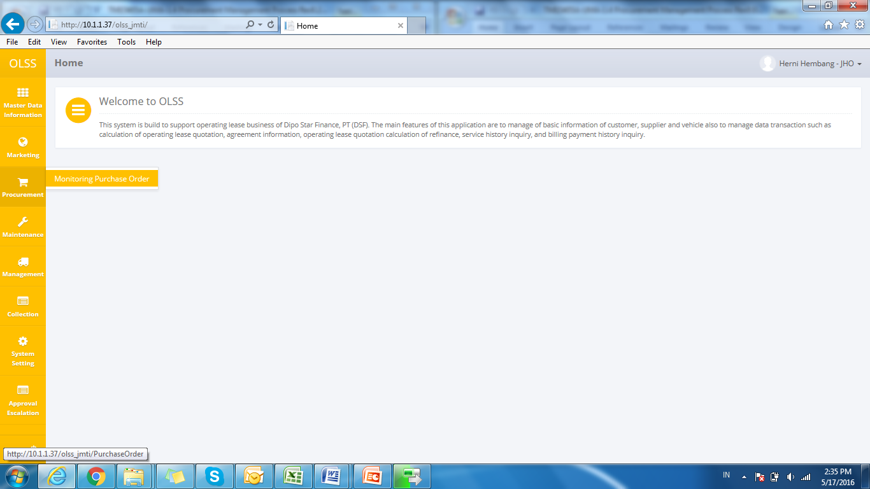

Screen 1: Procurement Menu

1. System will show List of Purchase order at Procurement screen that consist of purchase order that already recorded in the system. The main page of List of purchase order is shown below:

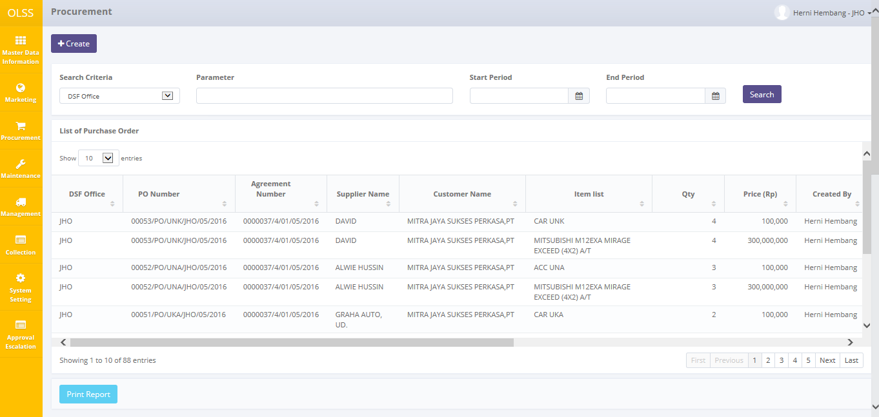

Screen 2: List of Purchase order Information Inquiry

User can see information such as:

DSF Office, Agreement Number, Customer Name, PO Number, Supplier Name, Item List, Quantity, OTR Price, Created By, Created Date, Last Update By, Last Update Date, Status, Action, and Action button (View, Edit, Print).

Purchase order statuses are divided into 8 types:

1. , the document hasn’t been submitted by PIC OPL, still can be edited.
2. , the document has been submitted by PIC OPL, can no longer be edited, and ready to be checked by DSF management.
3. , the document has been checked by DSF management, and continues to the next approval hierarchy.
4. , the document has some mistakes and the Checker has revised it. Document need to be submitted back by PIC OPL.
5. , the document has been approved by the highest hierarchy.
6. , the document has been rejected by the highest hierarchy.
7. , the document has been escalated by previous checker.
8. , the document has reached the end contract.



On the List of Purchase order screen, there will be five buttons, which are:

* 1. : On top-left screen, click the button to create new purchase order.
  2. : In the action column in each record, click the button to view purchase order details.
  3. : In the action column in each record, click the button to modify purchase order information.
  4. : In the action column in each record, click the button to print purchase order form.
  5. : On bottom-left screen, click the button to print report purchase order list.

## Filter and Sort Purchase Order List

To filter the records there are three categories as follows:

1. To sort the record alphabetically by column, user can click  on the column title on the table header.
2. User can select the number of records that want to be showed by picking this feature  on the screen. If the records have been filtered based on number, the amount of records that will be shown is the same as the selected number.
3. User can filter the records with the specific information by entering the keywords on the search field shown below:

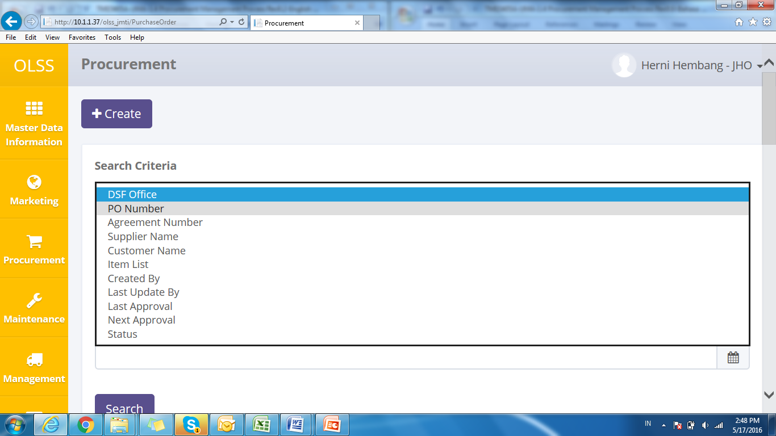

Screen 3: Search Criteria

Search criteria consist of data master:

Parameter can be filled with keywords that user want to search. To get more specific results, user can also insert the purchase order date (Start PO Creation Date and End PO Creation Date). For example, you can find name by filling the keywords in parameter, and pick **Customer Name** in Search Criteria, then pick the exact date, and press Search button to get the results.

## Create Purchase Order

To create purchase order, find and click Create on top of the Procurement Screen.

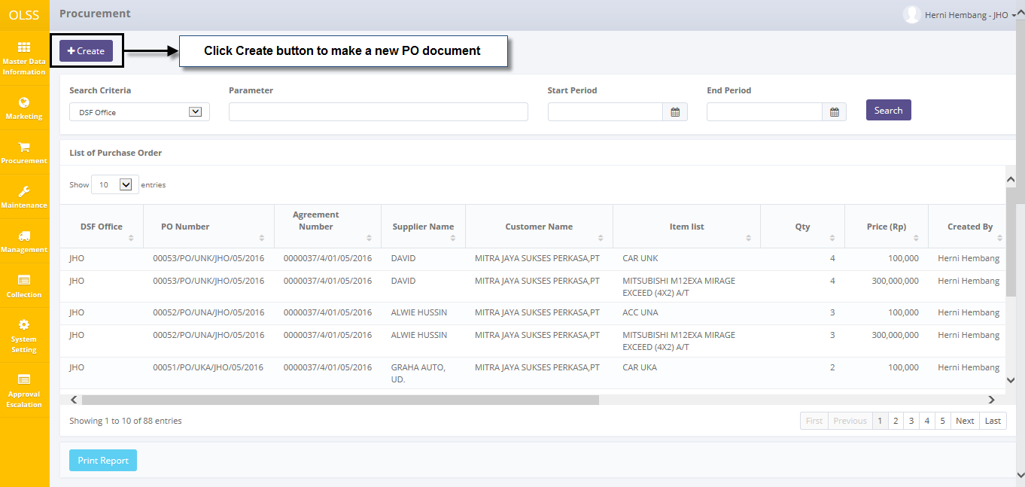

Screen 4: Navigate to Create Purchase order

System will show Create Purchase Order Screen shown below:

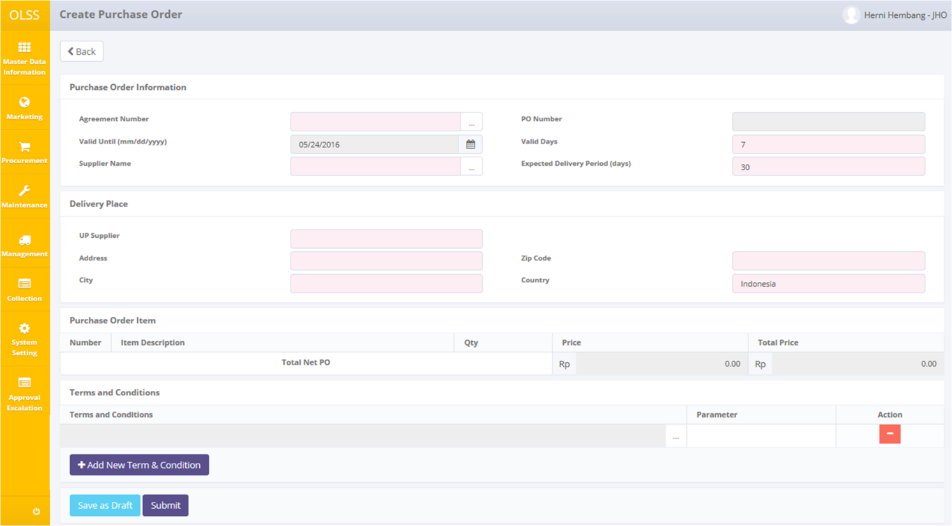

Screen 5: Screen of Create Purchase order

Once the Create Purchase Order screens open, user has to fill information on the blank field. The fields are:

1. Purchase Order Information:
   1. Agreement Number: search and select agreement number.
   2. PO Number: Automatically generated after user save document as draft or submit. PO format number is varied based on item type. The format number is:
      1. 00001/PO/**UNT**/CAB/MM/YYYY: Unit
      2. 00001/PO/**KAR**/CAB/MM/YYYY: Carrosseries
      3. 00001/PO/**ACC**/CAB/MM/YYYY: Accessories
      4. 00001/PO/**UNK**/CAB/MM/YYYY: Unit and Carrosseries
      5. 00001/PO/**UNA**/CAB/MM/YYYY: Unit and Accessories
      6. 00001/PO/**KAC**/CAB/MM/YYYY: Carrosseries and Accessories
      7. 00001/PO/**ALL**/CAB/MM/YYYY: Unit, Carrosseries, and Accessories
      8. 00001/PO/**MNT**/CAB/MM/YYYY: Maintenance
   3. Valid Days: show default days: 7 days
   4. Valid Until (mm/dd/yyyy): automatically show date by calculating valid days inputted.
   5. Supplier Name: search and select supplier name. Supplier showed based on supplier inputted in SKD. *Supplier that already selected on PO creation will not showed

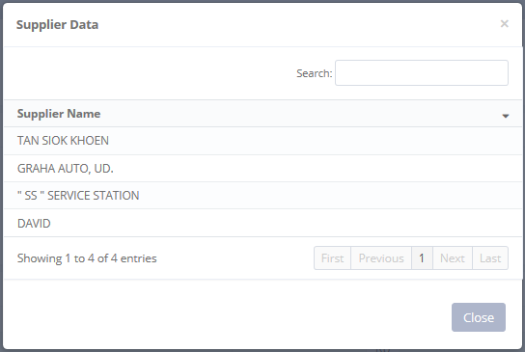

Figure

* 1. UP (untuk pembelian): input UP name.
  2. Expected Delivery Period (days): input estimated days for item delivery.
  3. Delivery Place: input delivery address location.

1. Purchase Order Item

Automatically show item listed for supplier selected.

1. Terms and Conditions

Show terms and condition for item listed. If user wants to add more terms and condition, first click 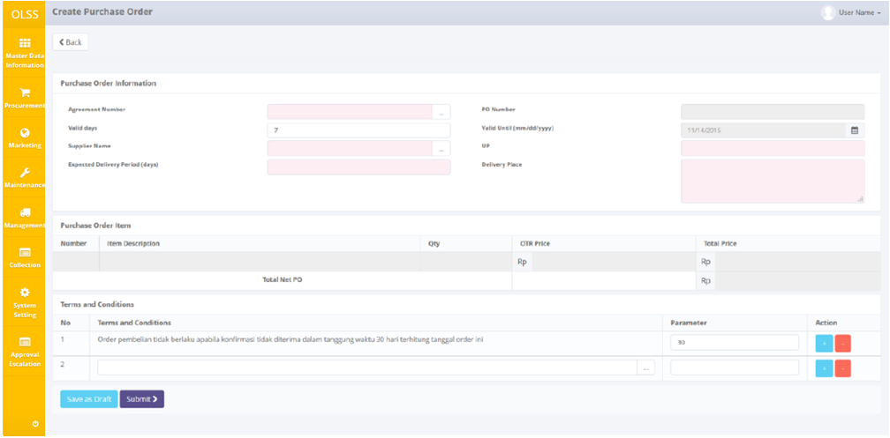 button. Then click button.

...

Pop-up dialog will show, then search terms and conditions that have been inputted, or click Add New Term button to add new terms and conditions.

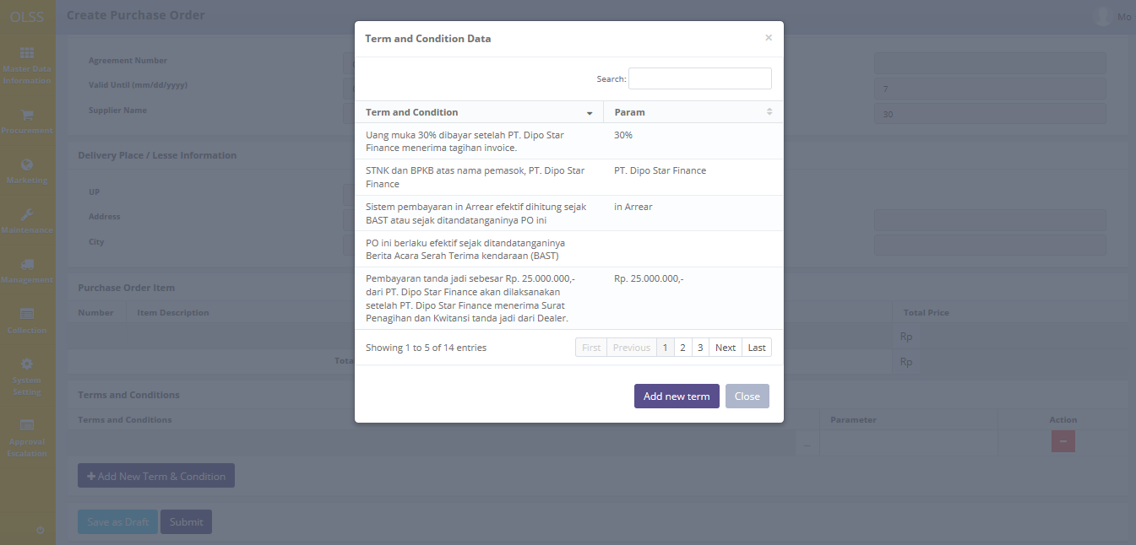

Figure

Add New Term and Condition pop-up dialog will show, and fill necessary information:

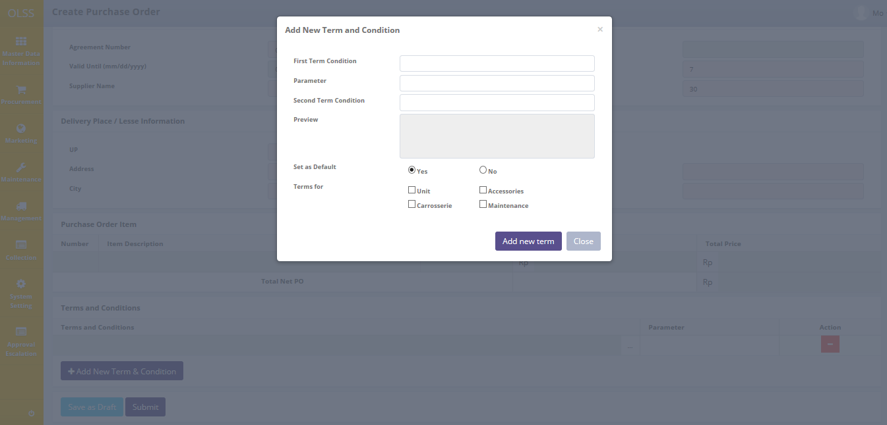

Figure

* First Term Condition: input information for first sentences, before “days parameter”.
* Parameter: input days, as bridging to second sentences.
* Second Term Condition: input information for second sentences, completing terms and conditions sentences.
* Set as Default: set as Yes or No.
* Terms for: apply for item type.

Click Add New Term button to finish adding term and condition, or click Close button.

There are three buttons that will be displayed on Create PO screen as follows:

1. , on the top-left corner of the screen.
2. , on the bottom-left corner of the screen, clicking this will made purchase order status into .
3. , on the bottom-left corner of the screen, clicking this will made purchase order status changed into .

After the data entered on the screen, user can save the information on the system by clicking **Save as Draft** button, or **Submit** button. Ensure that you actually want to **Submit** a record, because the records can’t be reserved and update after submitted by PIC.

There are mandatory fields marked with red background field that should be inputted and it can’t leave as blanks. If you leave them blanks, system will notified it after you clicking **Save as Draft** or **Submit** button.

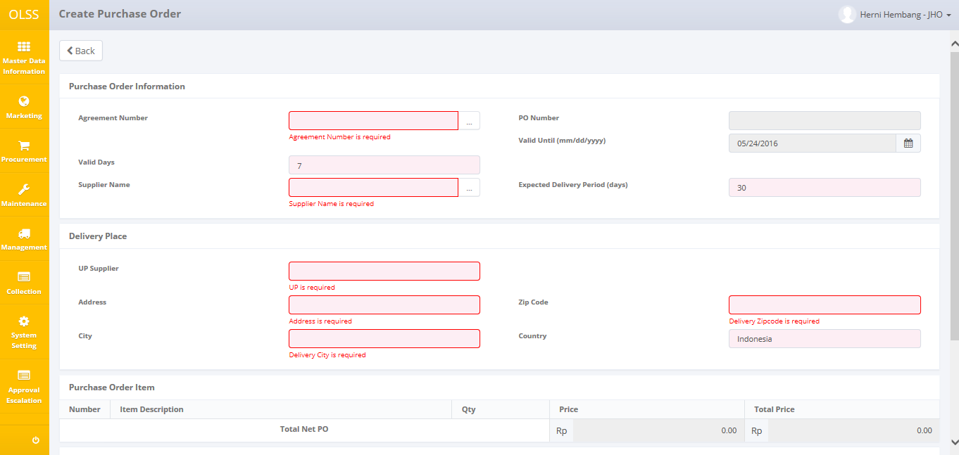

Screen 6: Error notification after Save as Draft/Submit

After clicking **Save as Draft** or **Submit** button, confirmation dialog will show up. Click yes to save document.

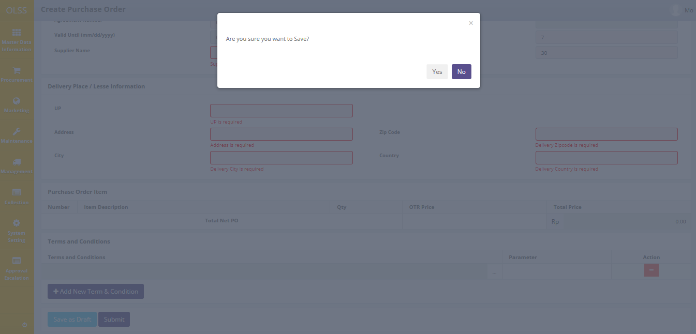

Screen 7: Confirmation Pop Up after Save as Draft

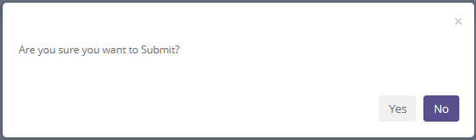

Screen 8: Confirmation Pop Up after Submit

System will notified if it success or failed to save or submit a data.



Screen 9: Success notification after Save as Draft

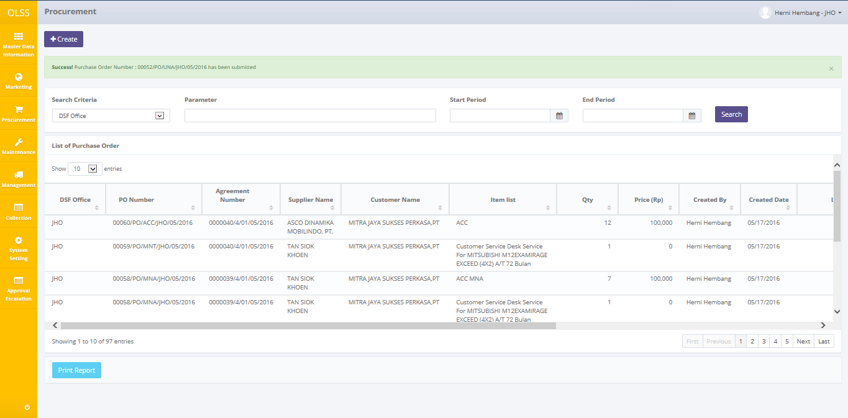

Screen 10: Success notification after Submit

## Edit a Draft or Revised Document of Purchase order

To edit purchase order record, navigate to the List of Purchase order and click Edit button on the right side of the record with status Draft or Revised.

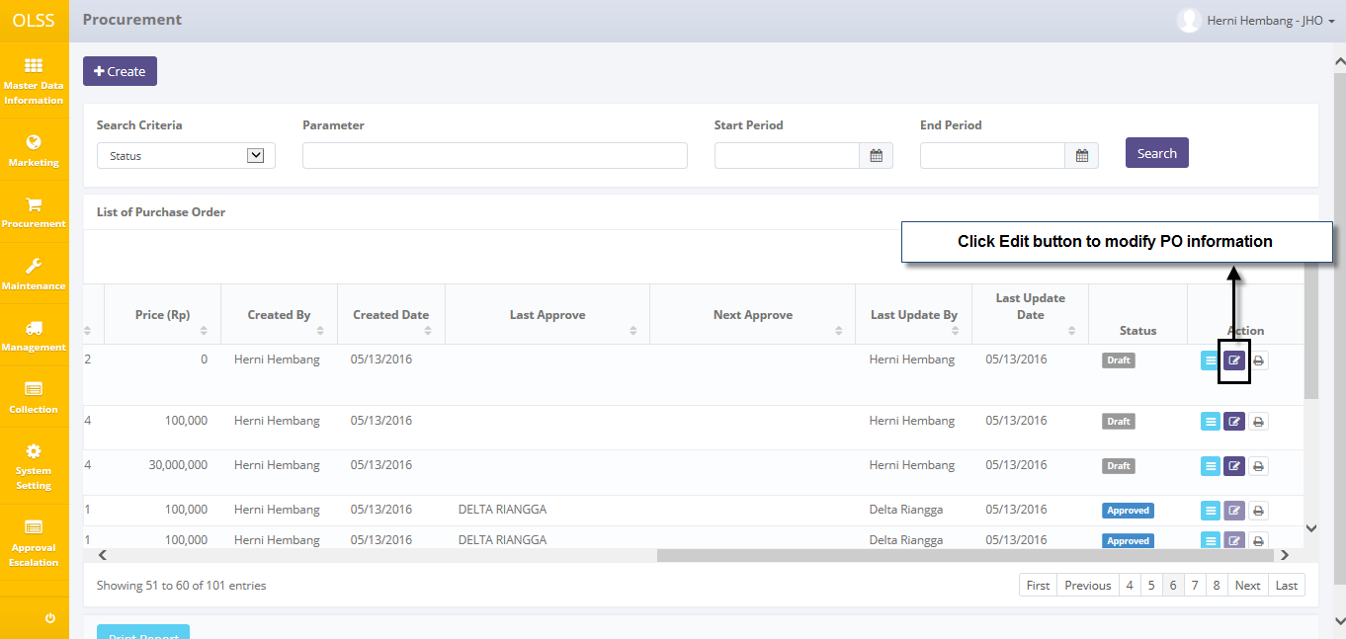

Screen 11: Navigate to Edit Purchase order

The screen below is shown after the Edit button is clicked.

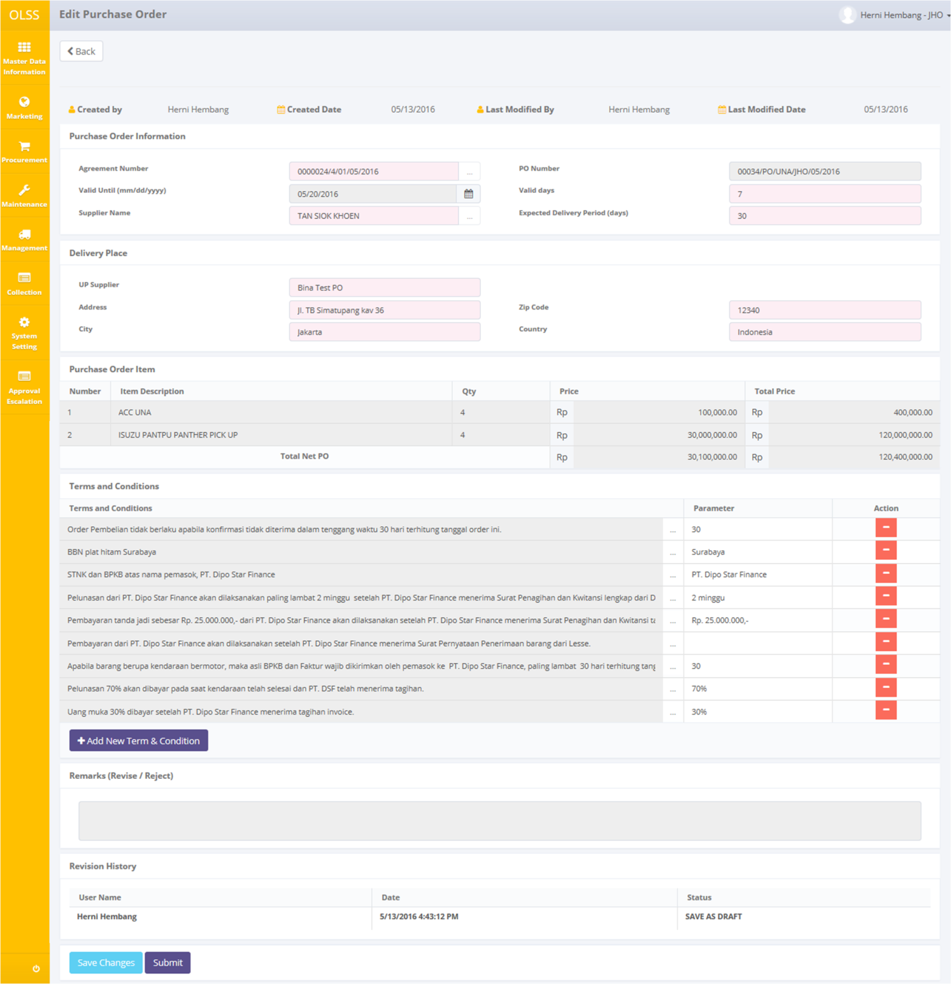

Screen 12: Screen of Edit Purchase Order

Once the Edit Purchase order screens open, user can edit existed information. There are three buttons that will be displayed on the screen as follows:

1. , on the top-left corner of the screen.
2. , on the bottom-left corner of the screen, clicking this will still make status into.
3. , on the bottom-left corner of the screen, clicking this will made purchase order status changed into .

There is a Revision History field on the bottom of the screen, consist of the user information that had make changes to the records. If data already changed on the screen, user can save a data on the system by clicking **Save Changes** button, or **Submit** button. Ensure that you actually want to **Submit** a record, because the records can’t be reserved and update after submitted by user.

There are mandatory fields marked with red background field that should be inputted and it can’t leave as blanks. If you leave them blanks, system will notified it after you clicking **Save Changes** or **Submit** button.

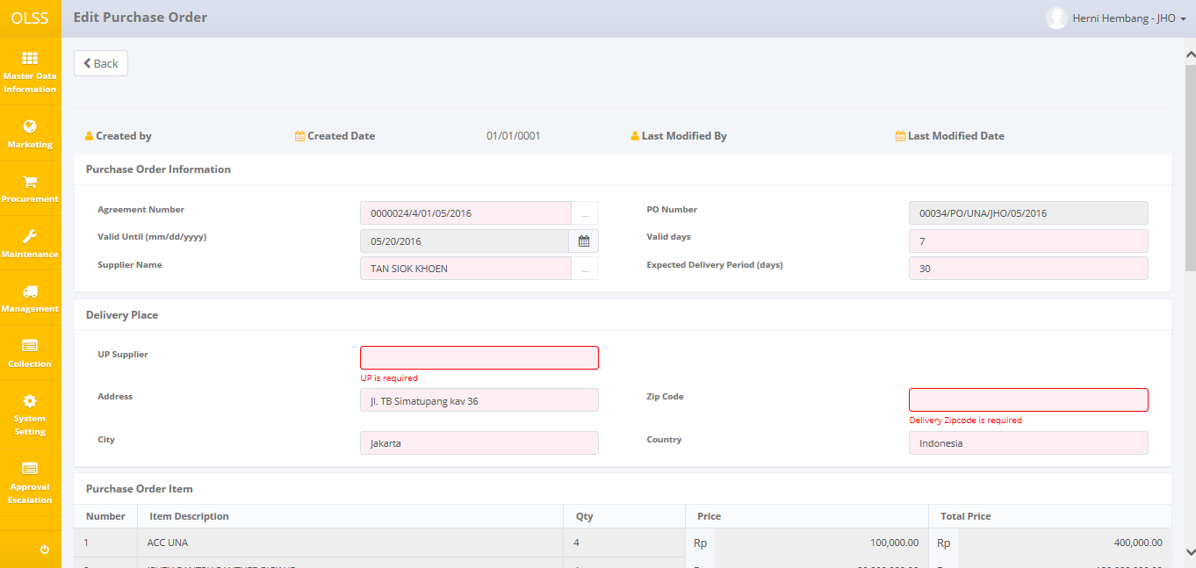

Screen 13: Error notification after Save Changes/Submit

After clicking **Save Changes** or **Submit** button, confirmation pop-up dialog will show up. Click yes to save document.



Screen 14: Confirmation Pop Up after Save as Draft



Screen 15: Confirmation Pop Up after Submit

System will notified if it success or failed to save or submit a data. You also have a **Back** button, which redirect you to the previous page, Procurement page.



Screen 16: Success notification after Save Changes



Screen 17: Success notification after Submit

## View a Purchase Order Document

To view the records, you can select a record from the Procurement page by clicking the action button , on the rightmost column.

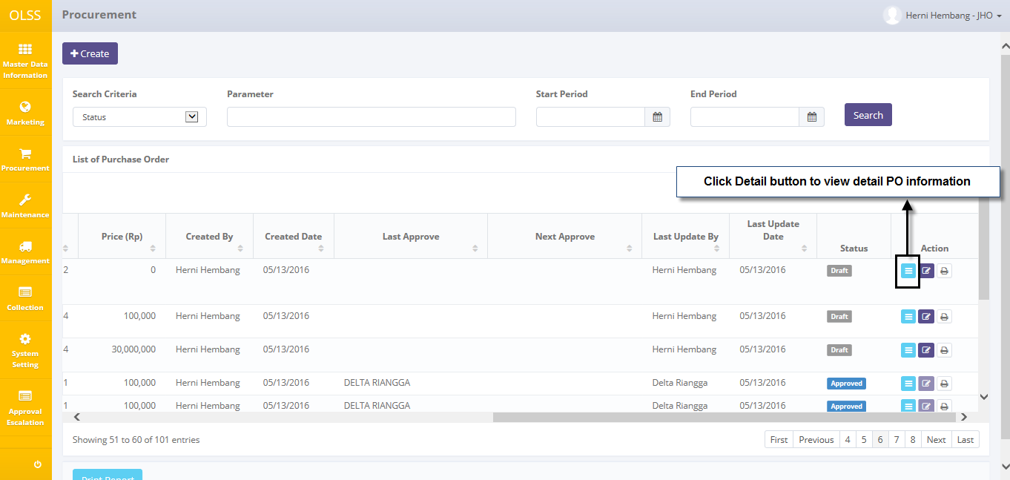

Screen 18: Navigate to View Detail Purchase Order

Screen will show View Purchase order screen shown below:

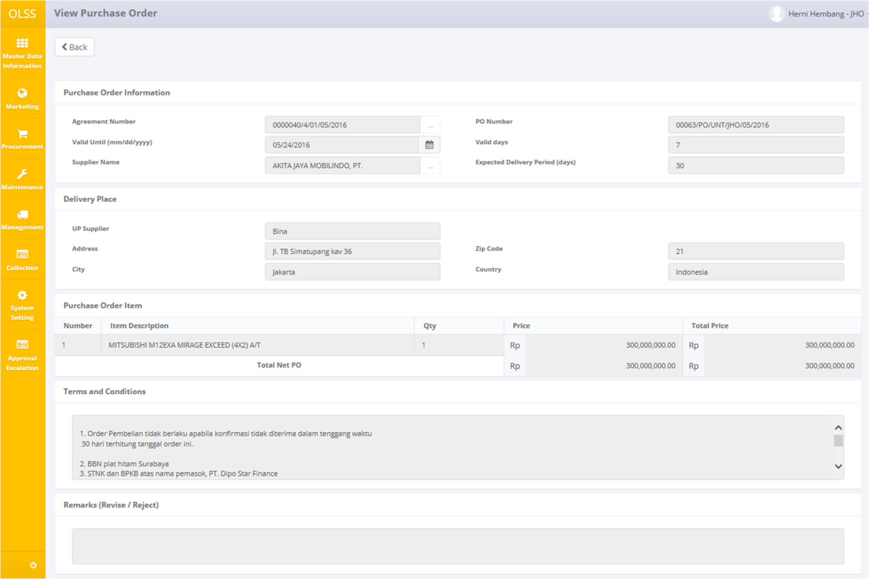

Screen 19: Screen View Detail Purchase order

User can check the records but the records cannot be clicked or edited. Here you can see the detail information related with Purchase order Data, such as; Purchase order Information, Purchase Order Item, Terms and Conditions, and Revision History. Click  on top of the screen to go back to previous screen.

## Print an Purchase order Form

User can also print the Purchase Order Form by clicking the button  on the Procurement screen as shown below:

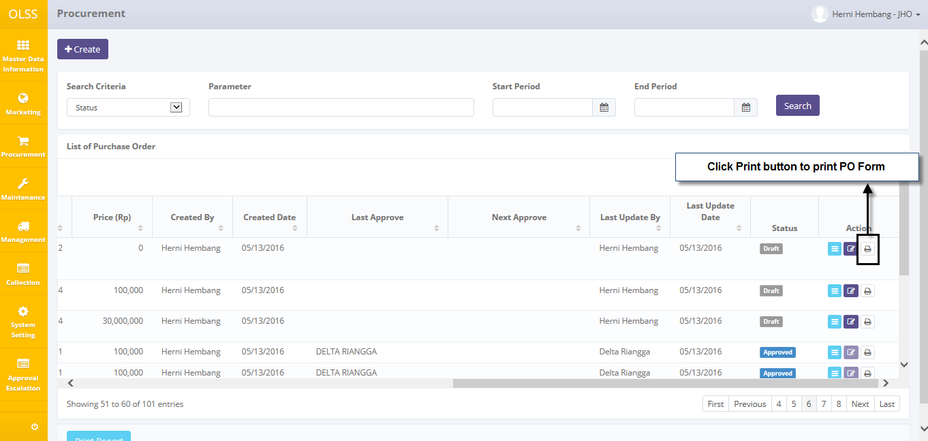

Screen 20: Navigate to Print Form Purchase order

After clicking the button, system will navigate to Purchase Order form print preview. User can print document as hardcopy, or save document as PDF or Ms. Excel.

## Print an Purchase order Report

Aside from printing Purchase order form, user can print the entire purchase order list that has been recorded. To print the report, user can click button on the bottom of Procurement Screen.

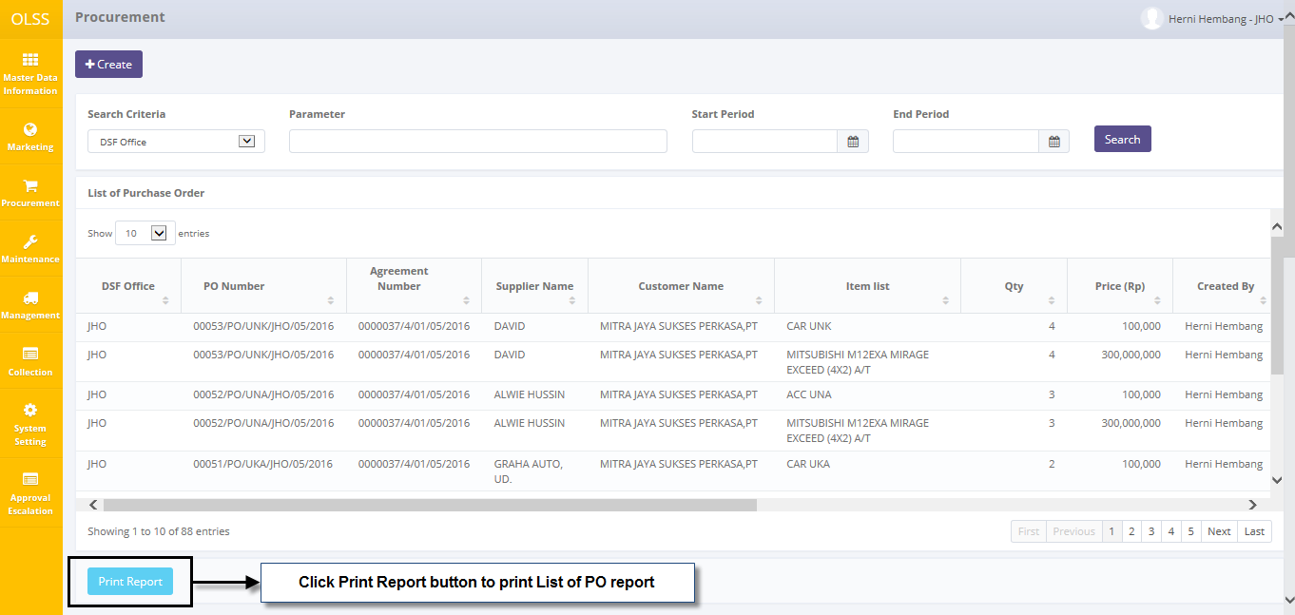

Screen 21: Navigate to Print Report Purchase order List

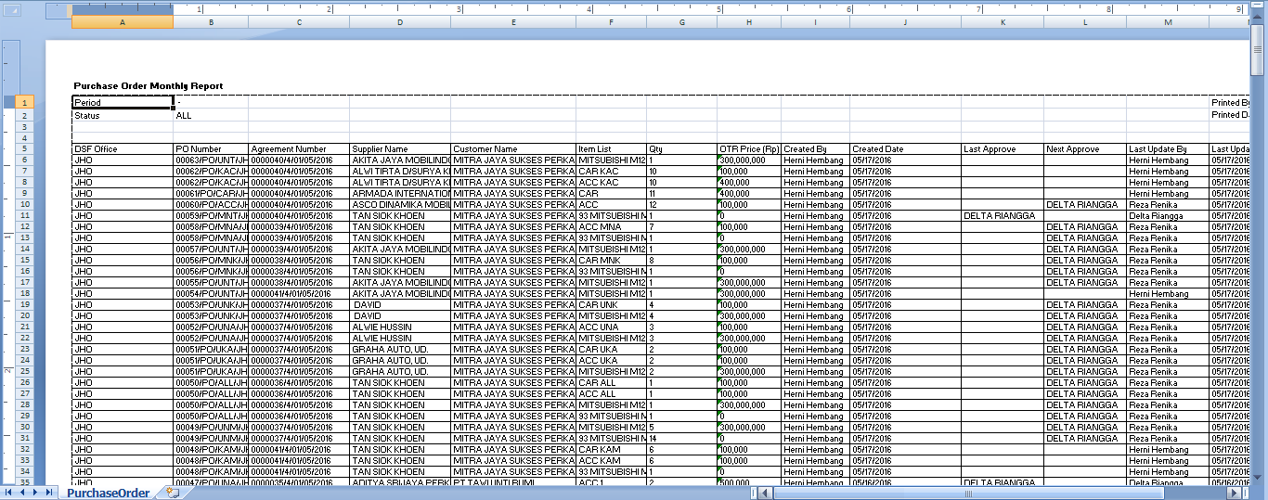

Screen 22: Report Purchase order List

# PURCHASE ORDER APPROVAL

Purchase Order Approval from authorized person is highly required in procurement process, including revision and submission. Purchase order can be approved once it is submitted by DSF PIC OPL. Purchase order document will be checked and approved by DSF management which is: Head of Branch/Head of Division, Regional Manager, Advisor, and Director. Approval hierarchy is based on PO amount. The highest the nominal, the higher hierarchy to check and approve PO. The nominal table can be seen below:

Table 1: Nominal Table

|  |  |  |  |
| --- | --- | --- | --- |
| **Amount Range (IDR)** | **Proposed** | **Checked** | **Approve** |
| 0 – 100.000.000 | MO | HOB | RM |
| 100.000.001 – 500.000.000 | MO | HOB, RM | Advisor |
| 500.000.001 - 1.000.000.000 | MO | HOB, RM, Advisor | Director |
| 1000.000.001 – 2.000.000.000 | MO | HOB, RM, Advisor, Director | President Director |

PO should be checked by one or more authorized person, before approved by the highest hierarchy user. PO approval flow (based on nominal table) can be described as:

Case 1: PO checked by HOB and approved by RM.

Case 2: PO checked by HOB, then checked by Regional Manager, then approved by advisor. If PO not available in certain time, it will be escalated manually to RM, which means the PO only checked by one person.

Case 3: PO checked by HOB, then checked again by Regional Manager, then checked by Advisor, last is approved by Director. If HOB not available in certain time, it will be escalated manually on to RM, if RM still not available in certain time, it will move on to the next authorized person: Advisor.

PO Approval process provides several functions:

1. View details of PO documents.
2. Check PO documents.
3. Approve PO documents.
4. Reject PO documents.

# Prerequisites

Before user can approve PO, user has to login using their own credential username, example: as HOB, RM, and director.

## Check and Revise PO

PO can only be checked by specific user. User who able to check is user stated in Next Approval column. To start checking PO record, navigate to the List of PO and click View button on the right side of the record with status .

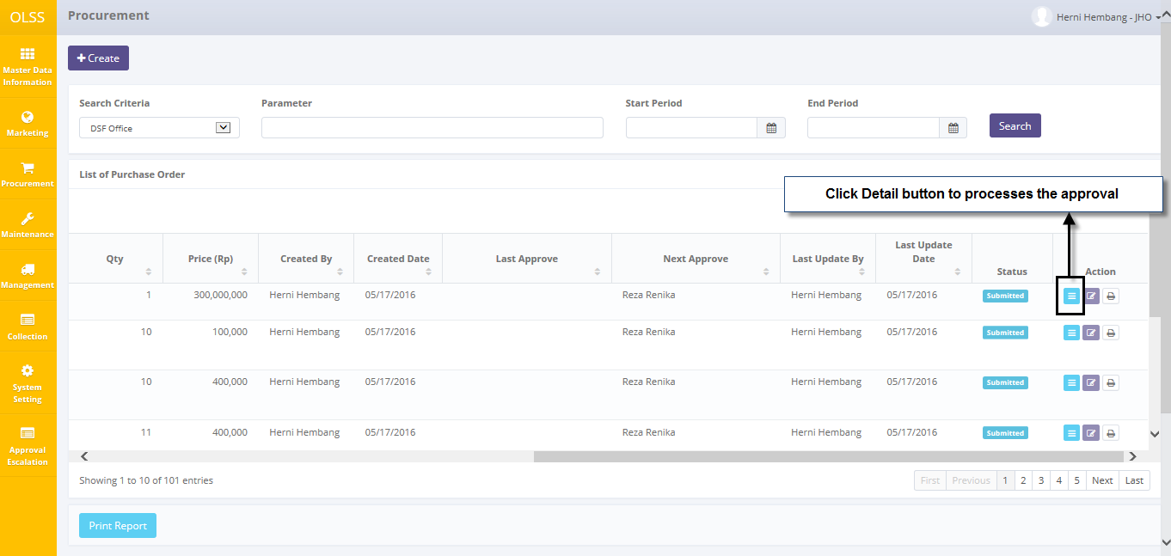

Screen 23: Details button on List of PO for submitted PO

The screen below is shown after the View button is clicked.

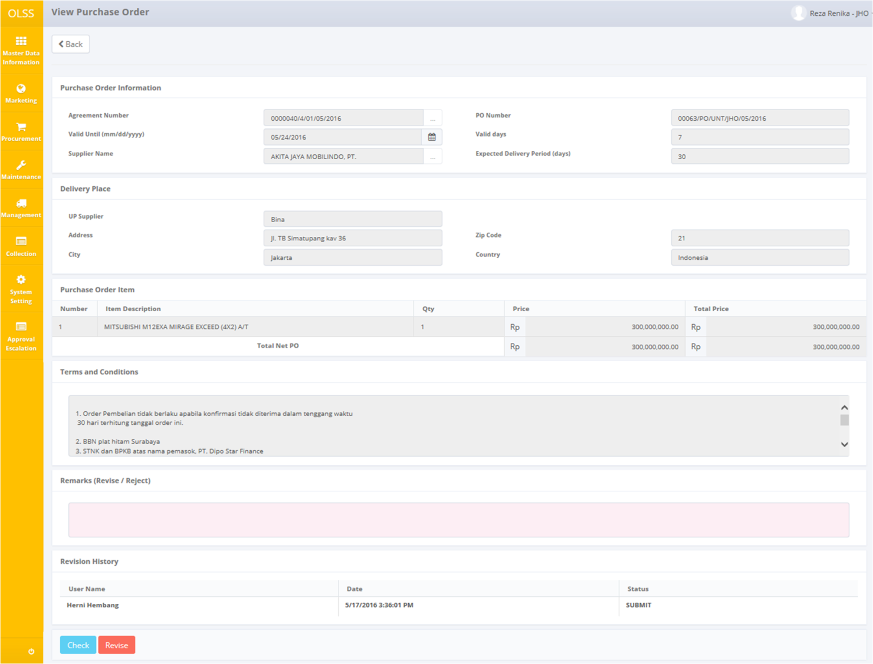

Screen 24: PO Details for Checker

Once the View Purchase Order screens open, user can check the information existed. There are three buttons that will be displayed on the screen as follows:

1. , to go to previous screen: Procurement.
2. , to give a sign that current approver has check the document and ready to send the document to the next approver, will not active for the highest hierarchy approver (refer to nominal table). PO document status will change to .
3. , to give a sign that the document need revision and have to be submitted again by Marketing Officer. PO document status will change to .

While checking, if PO still need to be revised, fill Remarks with revision information and click “Revise” button. The document will sent back to MO to be submitted back.

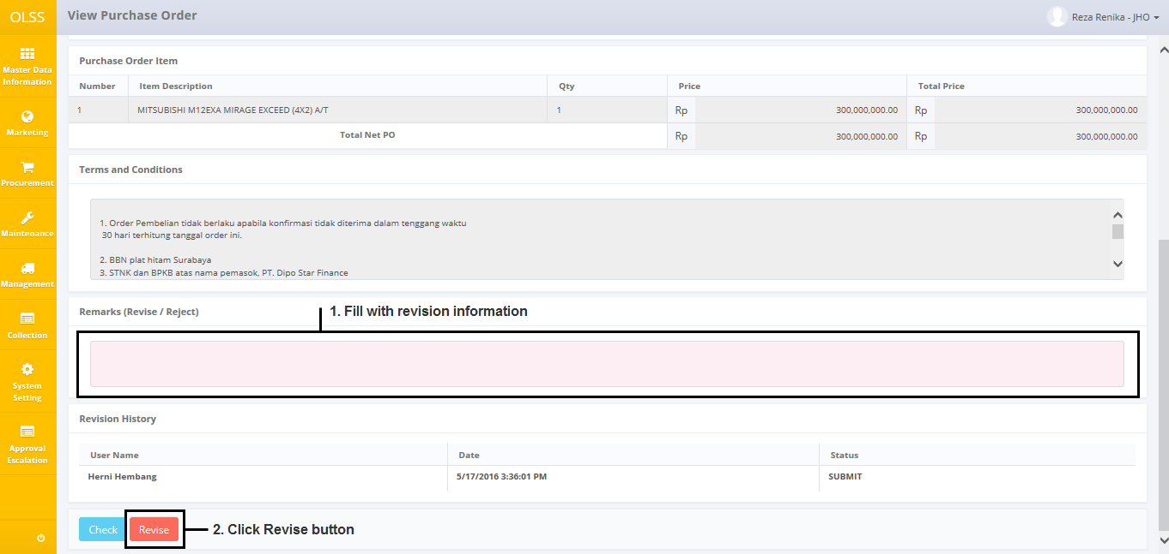

Screen 25: Revision step

If data has no more mistakes, user can click “Check” to continue the document to be checked by next approver. After clicking **Check** or **Revised** button, system will notified if it success or failed to save or submit a data.



Screen 26: Success notification after document is checked



Screen 27: Success notification after document is revised

System will automatically change screen to List of PO. Then the document can no longer be edit by current user, because the authority has been passed to the next approver. For this case, if HOB is the current user, HOB can’t edit the document.

## Approve or Reject Purchase Order

PO can only be approved by the highest hierarchy (refer to nominal table). To approve PO, click View button on the right side of the record with status  and has the highest hierarchy name as next approver. For example: if the highest hierarchy for the case is Director, then the “Next Approver” name should be Director Name.



Screen 28: Details button on List of PO for approver

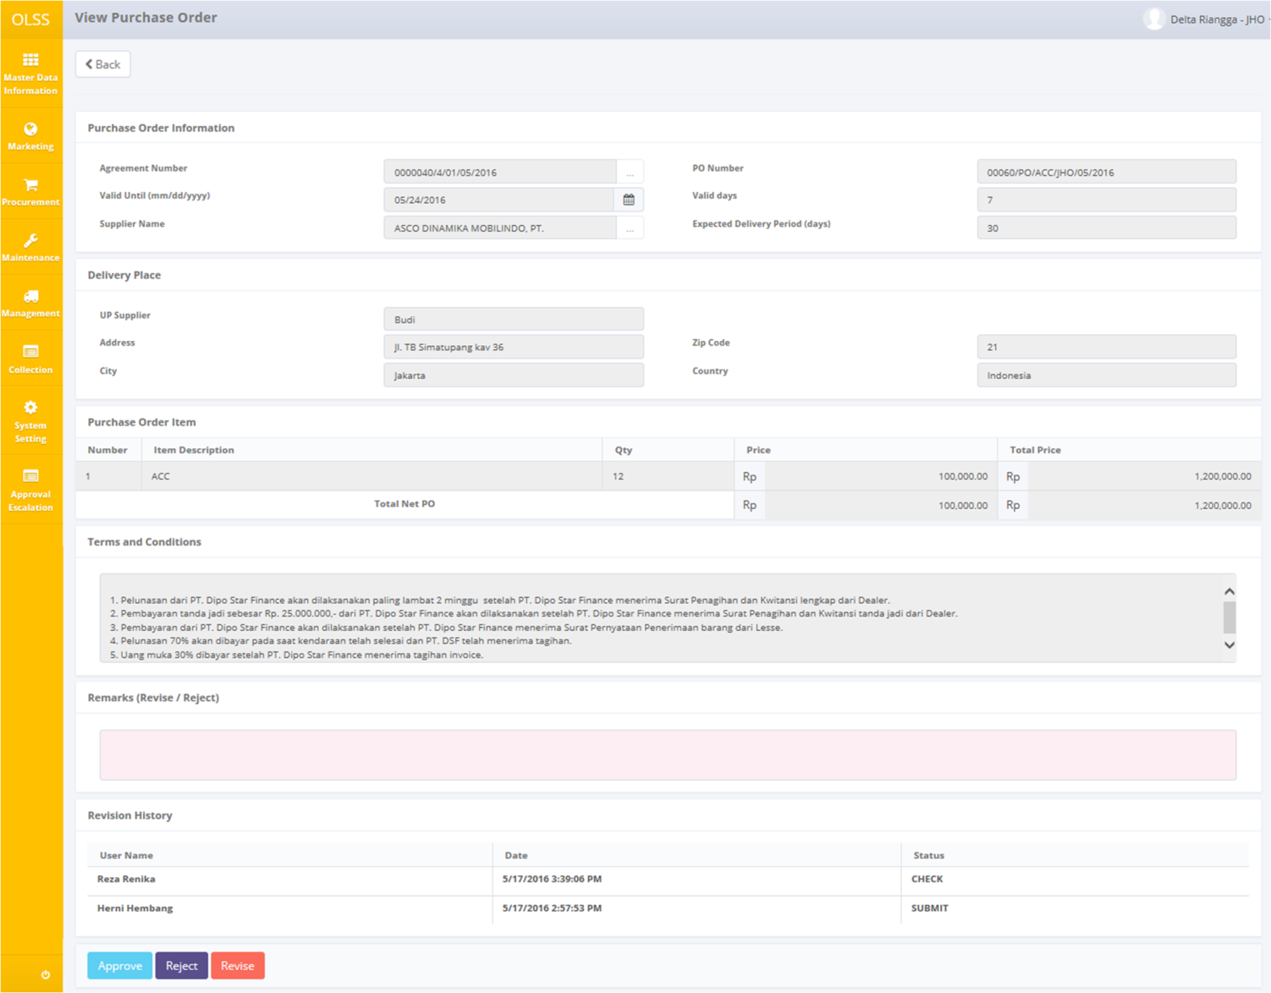

Screen 29: PO details for highest hierarchy user

View PO screen will show up, and on the bottom of the screen there are 3 active buttons:

1. , to give a sign that user has approve the PO. Only active for highest hierarchy user. PO status will change to .
2. , to give a sign that document is rejected by the highest hierarchy (refer to nominal table). PO Status will change to .

If PO will be rejected, user has to fill remarks with rejection reason. Then click Reject button on the bottom of the screen.

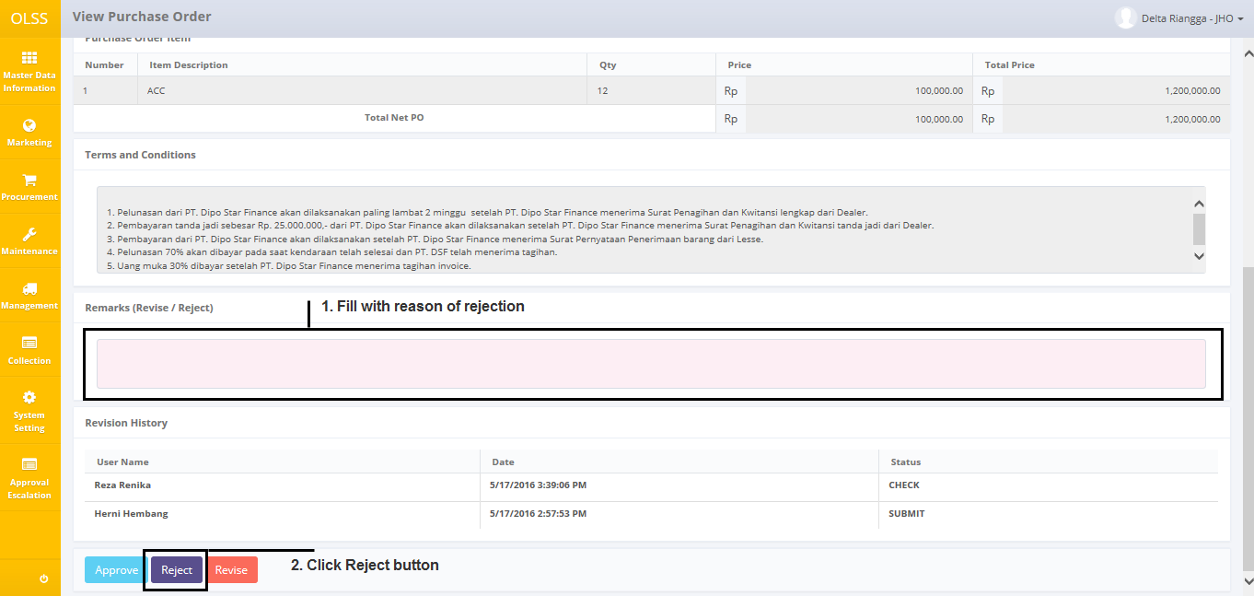

Screen 30: Rejection step

After clicking **Approve, Reject** or **Revised** button, system will notified if it success or failed to save or submit a data.



Screen 31: Success notification after PO is rejected



Screen 32: Success notification after PO is approved

Then the document can no longer be edit by current user, because the authority has been passed to Admin.